**Investor Dashboard** - Property, project dropdown [ Completed]

Which property & Project we are choosing, ie data Default.

**API**

|  |  |
| --- | --- |
| GET | **/investor/projectlists/{memid}/{memname}** |

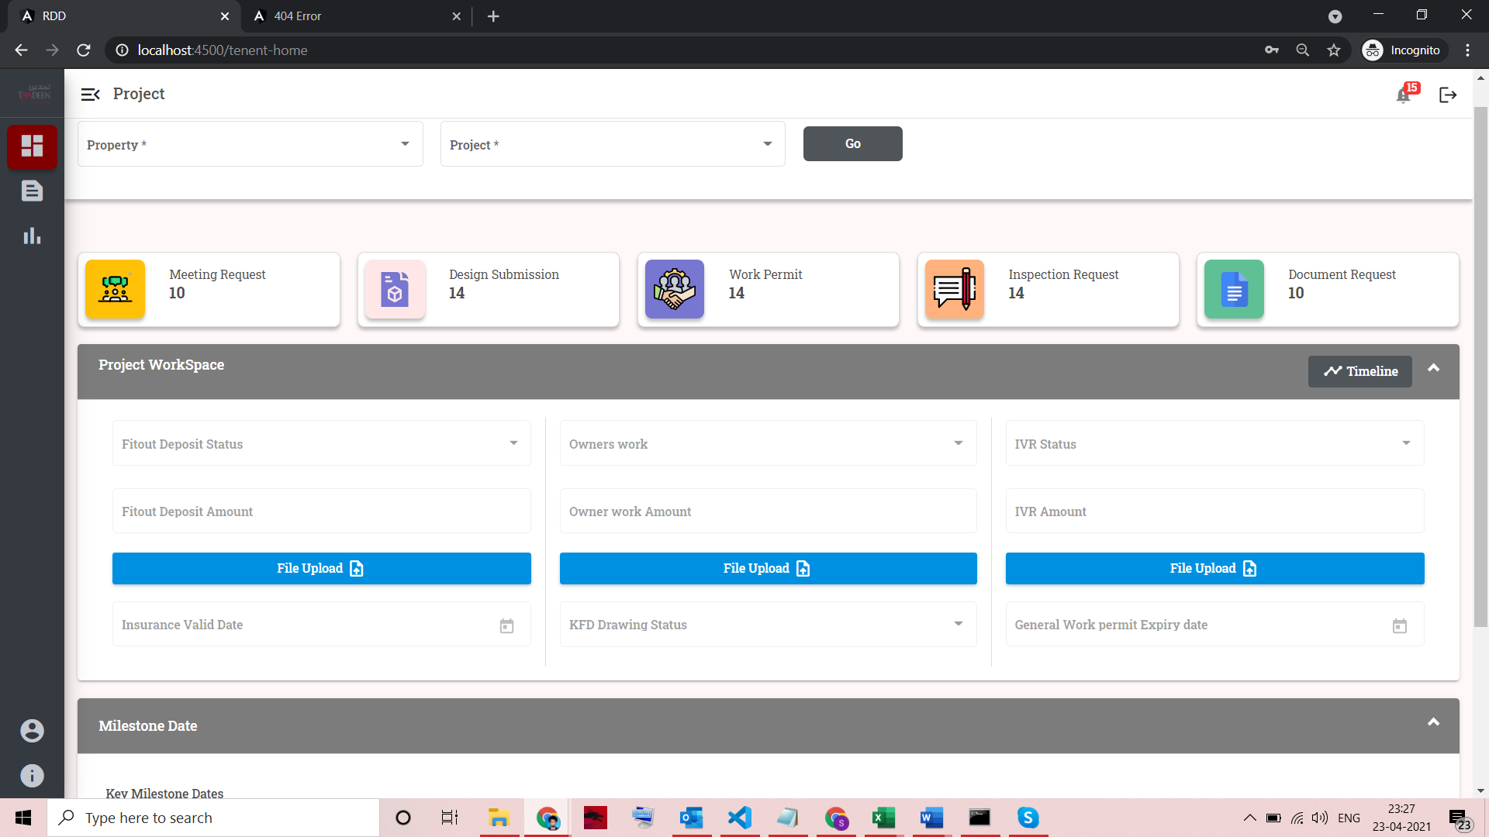

**Project Workspace, Tiles Count & Milestone Date [ Completed]**

|  |  |
| --- | --- |
| GET | /investor/projectworkspace/{projectid}/{propertyid} |

1. Hide file upload button, just comment
2. Only display data.

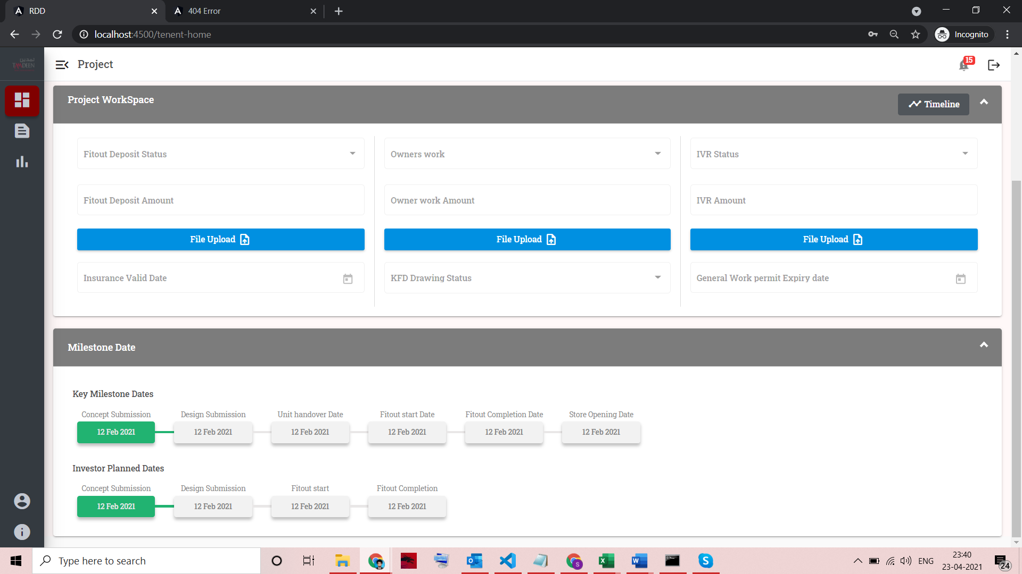

**Document page**

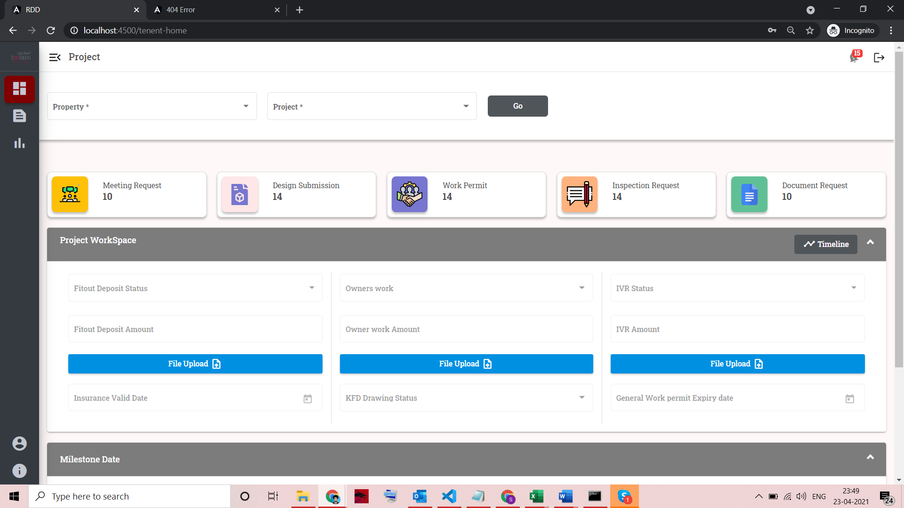

Click on Design submission.

|  |  |  |
| --- | --- | --- |
| POST | /investor/projectdoctasks | {  "project_id":83,  "property_id":2,  "org_id":"1",  "org_code":"ORG00001",  "project_name":"Meat&Eat2"  } |

Response doc_status value,  
  
0-not uploaded,1-uploaded,2-review&resubmit,3-approved  
--------------------------------  
org_id,org_code - get from login response

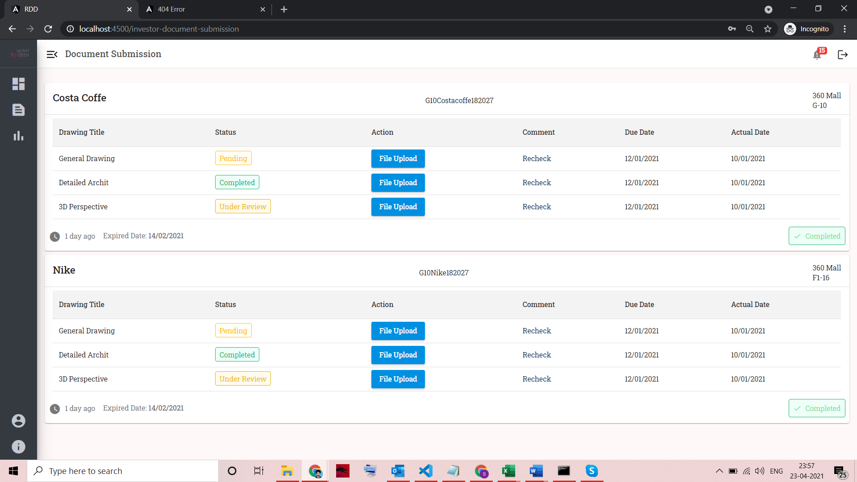.

**Save button API**

Investor updating document task & file path after uploading

|  |  |  |  |
| --- | --- | --- | --- |
| PATCH | /investor/updatedocstatus | {  "datas":[{  "project_id":"80",  "phase_id":"2",  "user_id":"1",  "docs":[{"doc_id":"159","file_path":"testpath/path"}]  }]  } |  |